DS Lab:

CYCLE_CO5:

Submitted by:SONI .R

MCA 134

DFS:

#include<stdio.h>

void dfs(int);

int g[10][10],visited[10], n;

void main()

{

int i, j;

printf ("enter the number of vertices:");

scanf ("%d", &n);

printf ("\n enter the adjacnecy matrix:");

for(i = 0; i < n; ++i)

{

for(j = 0; j < n; ++j)

{

printf("\n edge exist between vertices %d-%d :", i, j);

scanf("%d", &g[i][j]);

}

}

for(i = 0; i < n; ++i)

{

visited[i] = 0;

}

dfs(0);

}

void dfs(int i)

{

int j;

printf ("\n %d", i);

visited[i] = 1;

for (j = 0; j < n; j++)

{

if(!visited[j] && g[i][j] == 1)

{

dfs(j);

}

}

}

Output:

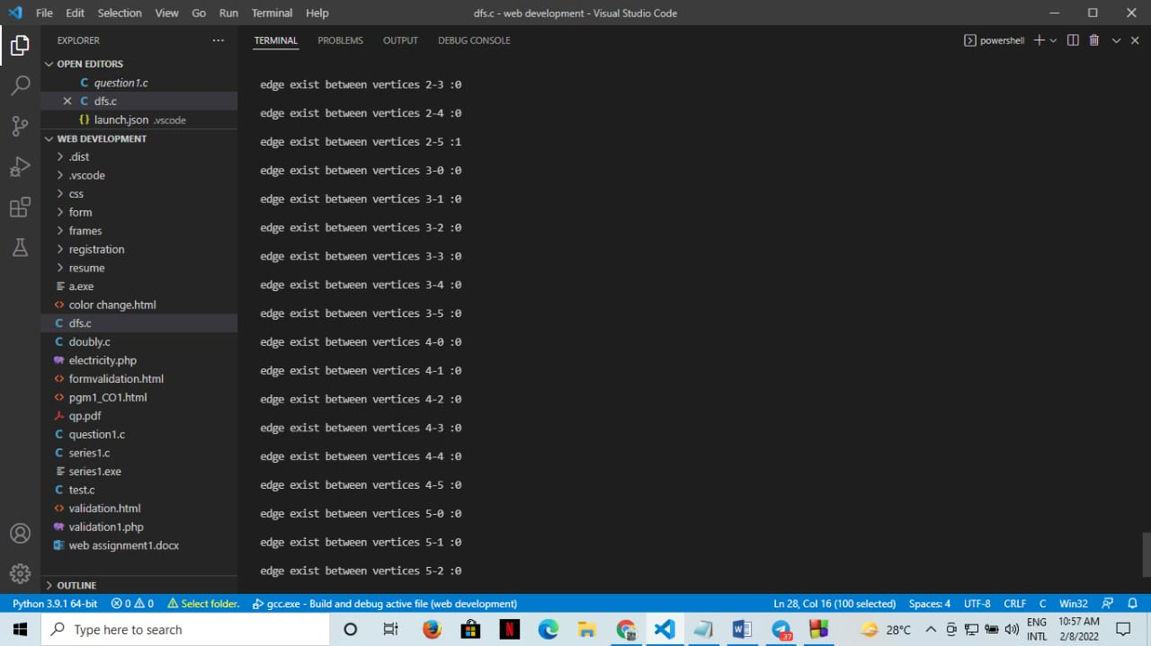



BFS:

#include<stdio.h>

int a[20][20],q[20],visited[20],n,i,j,f=0,r=-1;

void bfs(int v);

void main() {

int v; //call the value of starting vertex

printf("\n Enter the number of vertices:");

scanf("%d",&n);

printf("enter the adjecency matrix");

for (i=0;i<n;i++)

{

for (j=0;j<n;j++)

{

scanf("%d",&a[i][j]);

}

}

printf("\n Enter the starting vertex:");

scanf("%d",&v);

for (i=0;i<n;i++)

{

q[i]=0;

visited[i]=0;

}

bfs(v);

printf("\n The node which are reachable are:\n");

for (i=1;i<=n;i++)

{

if(visited[i])

{

printf("%d\t",i);

}

}

}

void bfs(int v)

{

for (i=0;i<n;i++)

{

if(a[v][i] && !visited[i])

q[++r]=i;

}

if(f<=r)

{

visited[q[f]]=1;

bfs(q[f++]);

}

}

OUTPUT:

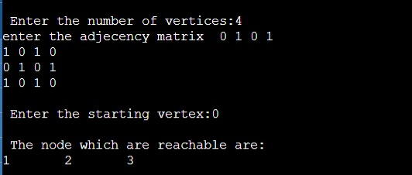

Kruskal:

#include<stdio.h>

#include<conio.h>

#include<stdlib.h>

/*int graph[v][v] ={{0,2,3,0},

{2,0,2,1},

{3,2,0,4},

{0,1,4,0}}

*/

int i,j,a,b,u,v,n,ne=1;

int min,cost=0,graph[9][9],parent[9];

int find(int);

int uni(int,int);

void main()

{

printf("\nEnter the no. of vertices:");

scanf("%d",&n);

printf("\nEnter the cost adjacency matrix:\n");

for(i=1;i<=n;i++)

{

for(j=1;j<=n;j++)

{

printf("Enter the edge weight of %d to %d ",i,j);

scanf("%d",&graph[i][j]);

if(graph[i][j]==0)

graph[i][j]=999;

}

}

printf("The edges of Minimum cost Spanning Tree are\n");

while(ne < n)

{

min=999;

for(i=1;i<=n;i++)

{

for(j=1;j<=n;j++)

{

if(graph[i][j] < min)

{

min=graph[i][j];

a=u=i;

b=v=j;

}

}

}

u=find(u);

v=find(v);

if(uni(u,v))

{

printf("edge (%d,%d) =%d\n",a,b,min);

cost +=min;

ne++;

}

graph[a][b]=graph[b][a]=999;

}

printf("\nMinimum cost = %d\n",cost);

}

int find(int i)

{

while(parent[i])

{

i=parent[i];

}

return i;

}

int uni(int i,int j)

{

if(i!=j)

{

parent[j]=i;

return 1;

}

return 0;

}

Output:

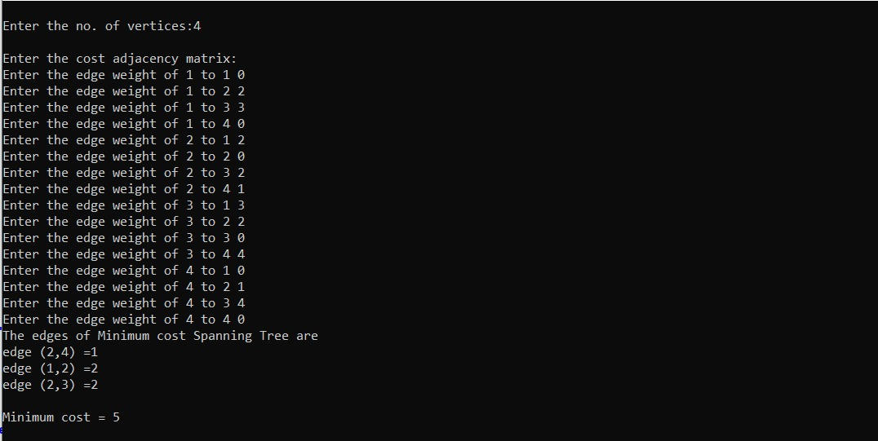

Prims:

#include<stdio.h>

#include<stdbool.h>

#define infinity 1000

//#define v 5

int graph[20][20];

int v;

/*int graph[v][v] = {

{0, 9, 75, 0, 0},

{9, 0, 95, 19, 42},

{75, 95, 0, 51, 66},

{0, 19, 51, 0, 31},

{0, 42, 66, 31, 0}};

*/

/*void display(){

for(int i=0;i<v;i++){

for(int j=0;j<v;j++){

printf("%d",graph[i][j]);

}

}

}*/

void mst(bool span[]){

int edge_count=0,total=0,x,y;

span[0]=1;

printf("\nEdge : Weight\n");

while(edge_count<v-1){

int cost=infinity;

for(int i=0;i<v;i++){

if(span[i]){

for(int j=0;j<v;j++){

if(!span[j] && graph[i][j]){

if(graph[i][j] < cost){

cost=graph[i][j];

x=i;

y=j;

}

}

}

}

}

printf("%d - %d : %d\n", x, y, graph[x][y]);

total+=graph[x][y];

span[y]=1;

edge_count++;

}

printf("\nTotal Cost=%d\n",total);

}

void main(){

printf("\nEnter the number of vertices ");

scanf("%d",&v);

printf("\nEnter the Adjacency Matrix \n");

for(int i=0;i<v;i++){

for(int j=0;j<v;j++){

scanf("%d",&graph[i][j]);

}

}

for(int i=0;i<v;i++){

graph[i][i]=0;

}

bool span[v];

span[i]=0;

}

mst(span);

}

Output:

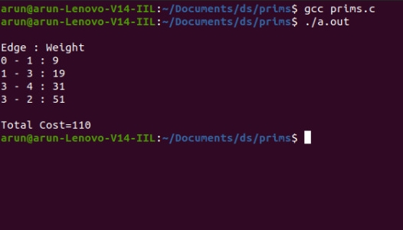

Topological sorting:

#include <stdio.h>

void main() {

int n = 0;

printf("enter how many vertex are there - ");

scanf("%d", & n);

int a[n][n], tp[n], f[n], x = 0;

//considering the vertices to be numbers

printf("\nEnter 1 if an edge exits or otherwise\n");

for (int i = 1; i <= n; i++) {

f[i - 1] = 0;

for (int j = 1; j <= n; j++) {

printf("Does an edge exists from %d to %d - ", i, j);

scanf("%d", & a[i - 1][j - 1]);

}

}

while (x < n) {

//finding indegree of all vertices

int in = 0, ind[n];

for (int i = 0; i < n; i++) {

for (int j = 0; j < n; j++) {

if (a[j][i] == 1) {

in ++;

}

}

ind[i] = in ; in = 0;

}

//Actual sorting

int t = 0;

for (t = 0; t < n; t++) {

if (ind[t] == 0 && f[t] == 0) {

f[t] = 1;

printf("%d ", t + 1);

break;

}

}

printf("\n");

//updating matrix with new values

for (int i = 0; i < n; i++) {

if (a[t][i] == 1) {

a[t][i] = 0;

}

}

x++;

}

}

Output:

